**CHAPTER-1**

**INTRODUCTION**

“The Internet of Things is a novel cutting-edge technology that offers to connect a plethora of digital devices endowed with several sensing, actuation, and computing capabilities with the Internet, thus offering manifold new services in the context of an intelligent environment.” These improvements and methods are credited with improving the quality of human life across various sectors, including healthcare, education, administration, city planning, energy consumption, etc.

“Gartner, Inc. forecasts that the enterprise and automotive Internet of Things (IoT) market will grow to 5.8 billion endpoints in 2020, a 21% increase from 2019.” Retrospectively, that adds up to a large number of interconnected devices. Studies and estimates project that by 2030, the worldwide count of IoT devices may be as large 125 billion.

“The Internet of Things (IoT) is a revolutionary communication paradigm that aims to bring forth an invisible and innovative framework to connect a plethora of digital devices with the Internet.” The primary focus of IoT as a concept is to make the internet universal and remotely accessible to all. After many years of its existence, IoT is continuing to gain momentum as the opportunities it offers are endless.

An IoT-based smart eco-system can be broadly defined as a large number of interconnected devices. Each of these devices have the capability to generate a vital piece of information and possesses the sensibility and infrastructure to share it with the other devices in the network. “IoT devices can use any available communication networks such as public Wi-Fi, Bluetooth, cellular networks (LTE/LTE-Advanced), and satellites to communicate with the cloud-based application center.” Some of the challenges faced in terms of the connectivity of the IoT devices are as follows:

• It is challenging to provide a strong and stable connection to mobile devices such as vehicles.

• Transition from low level to high level connectivity

• Communication devices must be present in addition to the large number of IoT devices, especially if they are spread over a large area.

The first step in creating innovative solutions to a problem is to identify and thus understand the problem itself and the scope of impact it has. This can be followed by an idea on how the Internet of Things can play a role in tackling such a scenario. High investment costs and security deter university managements from implementing a fully IoT-based eco-system. Our project hopes to take the first step in this direction.

Keeping the above scenario in sight, our goal is to identify and solve the most common problems faced in any educational institution, taking our own university as a canvas.

For a long time, attendance has always been taken manually. This has caused multiple discrepancies and has wasted useful class time. In addition to this, classroom equipment like fans etc. have occasionally been left on thereby wasting considerable energy.

Our approach is a fully edge computed, integrated biometric-based solution for attendance which is modular and carried by the teacher to ensure security. An ambient and spatial sensor-based approach to dynamically turn on and off the fans and lights based on the occupants of the room.

**CHAPTER-2**

**PROBLEM STATEMENT**

A proposal for an IoT-based intelligent environment, with the primary objective of energy optimization and an intelligent, yet reliable attendance system that focuses on reducing latency to give an enhanced learning experience.

Any educational organization (it maybe small or large) requires a students or employees attendance tracking system for the effective maintenance of different projects and tasks assigned to them. The management finds it absolutely necessary to collect and maintain up to date attendance data, sometimes even over a span of several months. This not only shows professionalism but also is crucial in case of any discrepancies in the future. We have seen that manual attendance tracking is a very tedious and inefficient process for even a fairly large group of students. Hence, an automated system of attendance takes a huge leap in this scenario.

A smart attendance system is very essential in present days. An effective and adequate system of attendance helps in monitoring the punctuality and progress of students and also, managing the absence of people. There are a few steps to enabling a smart attendance system. It consists of setting up the workflows for attendance and also maintaining a proper validation of student’s effective class time. However, this should be implemented by keeping the sensitive nature of data in mind. The chances of bypassing such a system must be minimized.

Another major issue observed in a university campus is the unrestrained use of electricity. This puts a direct strain on our country’s energy resources and in turn cause irreparable damage to the environment. As a responsible human, it is our duty to conserve the earth and leave behind a better world for our future generations. Unattended fans, lights and other electrical appliances account for a large portion of our country’s economy.

**CHAPTER-3**

**LITERATURE REVIEW**

**3.1 Smart University, A New Concept in IoT**

**3.1.1 Introduction**

The concept of smart environment in this given paper is defined like a small world where devices enabled by sensors and networking work together continuously to make the lives of those in the environment more comfortable.

Our university campuses boast a wide range of mobile as well as stationary devices that are connected to the Internet. This multitude of devices results in an enormous inter-connected network of smart objects, essentially giving birth to an Internet of Things, in its truest form. The interesting part in this scenario is that college campuses have varied types of such devices. The simplest ones being doors, windows, fans, printers, projectors, books, benches, etc. to the buildings, classrooms, canteens, etc. All these devices can be made intelligent by attaching sensors, QR tags, RFID, NFCs, thus bestowing upon them the ability to not only collect but also analyze a large volume of data and make decisions. These smart objects can collaborate to transform a traditional university, into a Smart University.

**3.1.2 Concept**

***The many sensors that can be attached to the various static and dynamic devices around the campus premises may give rise to the following mini smart eco-systems within the university:***

* Smart Parking: Monitor the parking system of the university and keep a note of the number of vacant spots in the lot to avoid jams at the entrance of the parking lot.
* Smart Lighting: Adjust the lights in the classroom automatically based on data received from sensors about the power of natural light, which in-turn will eventually help us reduce electricity consumption.
* Smart Tracking: Use of RFID technology to realize monitoring students inside the campus and their quick evacuation in emergencies; both goods and equipment can be monitored.
* Smart Inventory: Every component used (like CPU, printer, monitor, mouse, scanner, copier, etc.) will have a bar code associated with it which represents the inventory number and the QR tag. We can identify the component and display all of its information like technical specifications, administrator, etc. by connecting a device to the Internet with a barcode reader.
* Smart Food Redistribution System: One of the more humanitarian aspects and an absolute necessity in today’s world, the excess food from the college canteen can be transported to the nearest orphanage or hospitals. This would effectively reduce food wastage and also help those to need it.

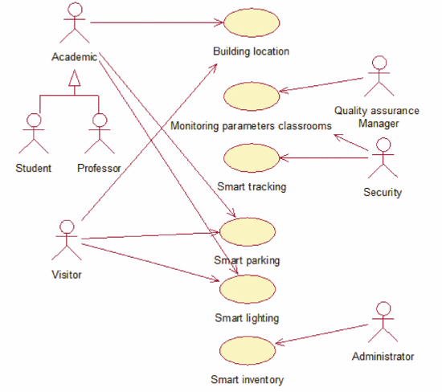

**Figure 1: Use Case Diagram for Smart University**

**3.1.3 Advantages**

***There are many advantages to smart universities, some of which are mentioned as follows:***

* Monitor and track the movement of students and employees across the various corridors, lecture halls spread across the university campus, giving rise to hotspots.
* Regulation of hallway traffic to avoid congestion; This could also be achieved by directing the traffic to the less occupied corridors and pathways dynamically.
* Increase safety and actively prevent accidents and disasters by constantly monitoring features such as noise, smoke, humidity, temperature, and lights in the halls of the organization.
* Consciously collect data from the various sensors and devices, store it in either a cloud-based server or on the university’s local server. This data can then be analysed and used to draw conclusions and develop a dynamic decision-making eco-system.
* Reducing electricity consumption and cut down the cost due to excess energy usage.
* Easily achieving the inventory of technology and equipment.
* Creating an environment conducive to increasing socialization in the university community.
* Using the data accumulated also by others in order to achieve various useful applications.

**3.1.4 Conclusion**

With the number of smart objects connected with IoT increasing regularly, it is normal to increase chances for converting traditional systems into some smart systems. The Smart University model can also be reused in part or as a whole in other domains, both in the educational field (universities, colleges, schools, kindergartens) and in other areas, including private business environment.

**3.2 Smart attendance system based on frequency distribution algorithm with passive RFID tags.**

**3.2.1 Abstract**

Maintaining a reliable attendance system forms a crucial part of any organization’s management. Many conclusions and managerial decisions can be made based on the staff attendance details.

However, the manual method is not only time-consuming but also riddled with high chances of errors. It also entails a constant risk of physical by-passing by some notorious staff members or students. Thus, a fool proof attendance system is an inseparable part of an organization’s management. Radio-Frequency IDentification (RFID) based attendance systems are better than their predecessors in their “strong anti-interference capability and non-intrusiveness”.

“This paper presents a smart attendance system that extracts distinguishable phase characteristics of individuals to enable recognition of various targets. A frequency distribution histogram is extracted as a fingerprint for recognition and the K-means clustering method is utilized for more fine-grained recognition of targets with similar features. Compared with traditional attendance mechanisms, RFID-based attendance systems are based on living biological characteristics, which greatly reduces the possibility of false records. Moreover, the system evaluation shows that our design is robust against differences in the clothing worn and time of day, which further verifies the successful performance of our system.”

**3.2.2 Definitions and Concepts**

**RFID module**

“An RFID tag in its most simplistic form, is comprised of two parts – an antenna for transmitting and receiving signals, and an RFID chip (or integrated circuit, IC) which stores the tag’s ID and other information. RFID tags are affixed to items in order to track them using an RFID reader and antenna.

RFID tags transmit data about an item through radio waves to the antenna/reader combination.

RFID tags typically do not have a battery (unless specified as Active or BAP tags); instead, they receive energy from the radio waves generated by the reader. When the tag receives the transmission from the reader/antenna, the energy runs through the internal antenna to the tag’s chip. The energy activates the chip, which modulates the energy with the desired information, and then transmits a signal back toward the antenna/reader.”

**K-means clustering**

K-means algorithm starts off by assigning random data points as centroids for the clusters. Then the centroids are re-adjusted iteratively.

The algorithm stops the above iterative process when one of the following two conditions are achieved:

• No change in the values of the centroids as compared to the previous iteration, i.e., stability is achieved

• k clusters (i.e., required number of clusters) have been formed

**Figure 2: System Workflow for Attendance System using RFID**

**Doppler Shifts:**

“When a body that is emitting radiation has a non-zero radial velocity relative to an observer, the wavelength of the emission will be shortened or lengthened, depending upon whether the body is moving towards or away from an observer. This change in observed wavelength, or frequency, is known as the Doppler shift.”

**3.2.3 Drawbacks**

Like all systems, this approach too is not flawless. One of the limitations of this system is that the entire system performance and evaluation metrics of the prototype is heavily dependent on just five volunteers, who were invited to participate in this laboratory experiment. We have little to no knowledge of how the results and deductions may be affected if the number of participants is significantly increased. The probability of a greater number of people having similar facial feature increases as the number of people increases. This is handled by making it more fine-grained.

Another major drawback of the system will be that there will be a noticeable latency in the feature extraction, making the implementation static. Real-time implementation must be the goal as it forms a key to building a robust and anti-cheating system.

**3.2.4 Conclusion and Further Work**

“In this paper, we proposed a device-free office attendance system and presented our key motivation, design methodologies, implementation, and evaluation of this system, which can distinguish various targets according to the unique phase signals of individuals in the LOS link, as collected from an RFID reader. To improve system identification accuracy, we used a frequency distribution histogram and a K-means algorithm to extract phase fingerprints. We conducted extensive experiments and the results show that our system performs very well, with an average accuracy of 92%. In future work, we will mainly focus on taking into consideration more phase features to achieve higher recognition accuracy in the identification of more targets.”

**3.3** **Automatic lighting and Control System for Classroom**

**3.3.1 Introduction**

India, although a developing country, suffers a serious issue in terms of the supply and demand chain of electricity. This is more pronounced in the smaller towns and villages that are often lacking the basic necessity of modern electricity. They still resort to the age-old techniques of oil lamps, thus putting our country’s growth back by a few hundred years. Even in the major cities, there still exists a problem of electricity shortage, which leads to people getting electricity for only few hours of the day only.

In the 21st century, electricity is a basic human necessity that is required to improve our country in the field of education, professional workforce, modern appliances for day-to-day chores, modern farming equipment, etc. The numerous villages are country are the ones that face the brunt of this unreasonable wastage of electricity. In order for the overall development of our country’s economy, we must pay heed to their energy requirements.

“Although our country has made significant progress towards the augmentation of its power infrastructure, the poor quality of power supply and frequent power cuts and shortages impose a heavy burden on India's fast-growing trade and industry.” The heavy dependence on non-renewable sources for the generation of electricity makes it even more precious and we need to exercise utmost caution in our expenditure of this energy. In light of the current scenario, we observe that educational institutions with a widespread campus such as colleges and universities play a pivotal role in misusing our country’s energy supply. Fan, lights, air conditioners, computers and other electrical appliances are perpetually switched on, irrespective of the presence of a student or faculty.

It is observed that in a few cases, all the fans and lights of a classroom are switched on irrespective of the presence of the students in one remote corner of the room. The amount of energy consumed and essentially wasted in the above scenario is huge.

**3.3.2 Methodology**

The entire smart lighting system for classroom are divided into parts which are Hardware sensing unit, Hardware processing unit, Hardware control unit, Network module and Mobile application modules.

The basic idea is to divide the classroom into several independent grids using motion sensors that will detect the arrival or departure of a student into a particular grid. The relays and Arduino Uno then work towards automatically turning on the fans and lights that exist in only that area.

• PIR Sensors – “PIR sensors sense the motion of a person whether they are in the range or outside the range. These sensors are small, inexpensive, low power, easy to use and don't wear out. They are often referred to as PIR, “Passive Infrared”, “Pyroelectric”, or “IR motion” sensors.”

• Arduino UNO – “The parameters such as temperature, humidity, etc have to be analysed, processed and corresponding action according to the stats are being triggered. An Arduino UNO is employed foe this task. “Arduino is a micro-controller and has its own programming language, used to control its functionality which is burnt on the board.” Arduino Uno is a microcontroller board based on the ATMega 328P. It consists of 14 digital I/O pins, 6 analog inputs, 16 MHZ Quartz Crystal, USB connection, Power Jack, ICSP header and reset button.”

• Relays – “Relay is an electrically operated switch which uses an electromagnet towards mechanically operating a switch. Relays are used in appliances where it is deemed necessary to control a circuit by low power signal or when several circuits need to be controlled by a signal.”

• Bluetooth module – “Bluetooth is a wireless technology standard towards data exchange over short distances at an ISM frequency band of 2.4 to 2.485 Mhz. IEEE standardizes Bluetooth as IEEE 802.15.1.”

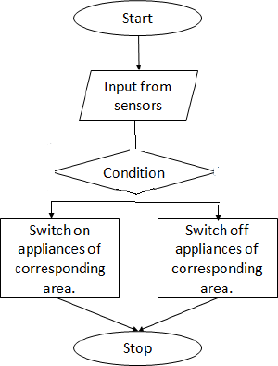

**Figure 3: Flowchart for Automatic Lighting and Control System**

**3.3.3 Implementation**

“The implementation of the entire Automatic lighting control system been carried out using Arduino Uno board. The Arduino microcontroller is responsible for switching the appliances on and off based on the input received from the PIR motion sensors.

**3.3.4 Conclusion and Further work**

India is a developing country and energy forms one of the major factors that influences our growing economy. Educational institutions, due to the vastness of their campus and the number of students and faculty, are one of the largest sinks that consume energy in our country. Most students and professors have inculcated the habit of leaving the fans, lights and other electrical appliances unattended, leading to a large amount of electricity being consumed unnecessarily. This in turn leads to an increase in the energy related costs of the institution. In order to avoid all of this, many sensor-based solutions have been proposed over the years. But sadly, none of them have found widespread acceptance.

In this paper, they have discussed a system in which the area of the classroom is divided into a number of equal grids by motion sensors placed at various vantage points. They detect the presence of a person in a particular grid, and send a signal to the relay to automatically switch on the corresponding fans and lights.

In future, research can be carried on towards not only switching the appliances on or off but also altering the intensity of lights and speed of fans on the basis of environmental factors such as temperature and humidity. Additionally, a timer feature maybe implemented in addition to the system in order to automatically turn off the appliances, thereby conserving electricity.

**3.4 Smart Attendance Monitoring System (SAMS):**

**3.4.1 Abstract**

In any institution, attendance records hold a lot of prominence in understanding the effectiveness of classes and helps in the management’s constant lookout to improve and enhance the experience of education for both students as well as faculty. Convenience and fault-tolerance are the most important aspects for any smart attendance system. The traditional method of calling out a long list of names is tedious and also time-consuming. This paper talks about a system which is developed by integration of omnipresent components to make a device (usually portable) for managing the students and faculty attendance using the Face Recognition technology.

**3.4.2 Methodology**

***Face Detection***

Face tracking technique has been employed for better accuracy of face-log generation. Firstly, the Viola-James algorithm is used to detect the face, which is then followed by the use of the correlation tracker present in the dlib library for keeping track of the face from one frame to the next frame. “This approach also saves computational power since we don’t have to detect the face after transforming to a new frame in the real-time video sequence.”

***Viola-Jones algorithm***

This algorithm was developed by Paul Viola and Michael Jones in 2001. It is an object-recognition framework that allows the detection of image features in real-time.

“Viola-Jones algorithm was designed for the front-view of the faces, so it is able to detect front profile the best rather than faces looking sideways, upwards or downwards. Before detecting a face, the image is converted into grayscale, since it is easier to work with and there’s lesser data to process. The Viola-Jones algorithm first detects the face on the grayscale image and then finds the location on the coloured image. Viola-Jones outlines a box and searches for a face within the box. It is essentially searching for these Haar-like features, which will be explained later. After inspecting every tile in the current box, the box moves a step to the right. The box size and step size can be adjusted according to need. With smaller steps, a number of boxes detect face-like features and the data of all of those boxes put together, helps the algorithm determine where the face is.”

**3.4.3 Performance of the system**

When a student is exposed to the SAMS for the first time, his/her face is detected and stored int the database. This information is then used to train the model in order to detect the same person in future instances. The system offers self attendance feature in which the GUI (Graphical User Interface) giving a drop-down menu for the recognized face. The drop-down menu consists of a list of most probable students whose face may have a certain degree of similarity. The first name given by the GUI in the drop-down menu has the highest probability for the match.

**3.4.4 Conclusion**

The primary goal of an automated attendance system is to overhaul the traditional and time-consuming system prevalent even today. The implemented system keeps track of attendance by detecting some facial features and then recognizing them. These systems perform convincingly with different facial expressions, poses of the person and lighting in the background.[5] However, one of the major drawbacks of this system is its inability to recognize valid faces from time to time.

**CHAPTER-4**

**PROJECT REQUIREMENTS SPECIFICATION**

# Product Perspective

We have observed that even if the classrooms have been hugely automated in most of the institutions, there are quite a few loopholes in the previously existing solutions which can be optimized to make the systems full proof. One of those problems is attendance systems. For a long time, attendance has always been taken manually. This has caused multiple discrepancies and has wasted useful class time. We have observed that even if it is automated, there are several flaws. In addition to this, classroom equipment like fans etc. have occasionally been left on thereby wasting considerable energy.

# Product Features

* Automated Attendance System:

A full proof attendance system using a fingerprint scanner attached to a mic system carried by the teacher such that there are minimum loopholes for the students to exploit.

* Electricity Optimization:

Estimating and reducing the average energy footprint of a classroom by using motion sensors to detect if there are students in a certain section of the classroom where the fans/lights are running and using temperature, humidity sensors for optimizing the classroom temperatures thereby aiming at providing a perfect environment to study.

* Cloud-based Dashboard:

Designing a cloud-based dashboard containing a detailed analysis based on the attendance information.

# User Classes and Characteristics

* Students:

The students take the fingerprint scanner from the teacher for every class, mark their attendance and pass it around as their attendance gets marked automatically for that particular class.

* Teachers:

The teachers carry the fingerprint scanner attached to the mic system they usually take to class. Their attendance is marked once the mic is switched on and then they would pass the fingerprint scanner throughout the class for the students to mark their attendance.

* System Admin:

The system admin monitors the attendance of the students and basically looks after the entire working of the attendance as well as the energy optimization system.

# Operating Environment

* Hardware available in campus: Relays, Wiring, Fans, Tube lights.
* Hardware required for the project: UART Capacitive Fingerprint Sensor, Digital Temperature Controller Thermostat, Tolako 5v Relay Module, PIR Motion Detector Sensor Module HC-SR501, Microcontroller: Raspberry Pico, Transmitter and Receiver.
* Software Components: Wireless Connectivity (Wi-Fi Module), Server: Agile, Django/ IoT Platform like ThingSpeak.

# General Constraints, Assumptions and Dependencies

* Availability of Raspberry Pico:

Raspberry Pico is very new to the market and needs to be tested whether it satisfies all the requirements for the project. As per the documentation, it does seem to satisfy them. As a backup, we would still have Raspberry Pi ready, but the cost would be more if we use Raspberry Pi instead of Raspberry Pico.

* Server systems in the Institutions:

Our project also highly depends upon how the server system exists at a particular institution. If there is no existing server, it would be very easy to implement. If there exists a server, then we have to check how exactly we will be able to implement our project on it.

* Existing Wiring in Institutions:

It depends which wiring system exists at the institution because our project would work on almost every existing wiring system unless it’s very old.

# Risks

* We assume that the server at the institutions is very easily compatible to our project.
* We also assume that existing wiring and relay system in institutions is not very old such that we cannot even implement our project on those systems.

# Functional Requirements

*Attendance Management System:*

The singular component of smart attendance management system involves analyzing and taking fingerprint scans of student and validating the same over a cloud database.

* Validity Tests Involved:
  + Every student of every classroom will have their individual fingerprints scanned and registered in the class’s database.
  + Upon commencement of classes, a scan of every student who are present is taken and validated in the database, thereby marking them present.
* Error handling and recovery:
  + Upon encountering an error, the student may request the teacher after through identification to manually mark the said student as present.
  + The database will employ its own error identification and correction techniques.
* Sequence of Operations
  + Student scans fingerprint
  + Scanner relays finger-print identification data wirelessly to microcontroller.
  + Microcontroller checks online database and verifies attendance.
  + Database logs in time and date as well.

*Classroom Energy Management:*

* Validity Tests Involved:
  + The power system of the classroom’s compatibility with relays must be ensured for a smooth functioning of power cutoff.
  + Bidirectional switch connections must be accounted for.
  + The temperature of the room is checked, and the speed of the fans is adjusted accordingly.
  + The temperature can be manually overridden.
  + In the event of the classroom being empty, power must be cut off to all equipment.
* Error Handling and Recovery
  + In the event of an error, circuit breakers are to break the circuit to prevent equipment failure.
* Sequence of Operations
  + Temperature is kept in constant check by the microcontroller.
  + As and when the temperature rises/falls, the fan speed is modulated.
  + When the occupants of the classroom leaves, the power to the lights are cut off.

# External Interface Requirements

# User Interfaces

* Dashboard for the teachers to view attendance.
* Interface for the teachers for manually provide attendance if the sensor fails.
* Controls for the teachers to perform analysis on the intake of students on a per subject basis.
* Controls for the system admin to oversee the registration and authentication of each student.

# Hardware Requirements

• UART Capacitive Fingerprint Sensor

• Absolute Native Electronics W1209 50~100 digital temperature controller thermostat

• Tolako 5v Relay Module

• PIR Motion Detector Sensor Module HC-SR501

• Microcontroller: Raspberry Pico/ Raspberry Pi

• Transmitter and Receiver for 1km range.

# Software Requirements

|  |  |  |
| --- | --- | --- |
| Wireless Connectivity | 1 | Wi-Fi Module Specifications:   * Model Number: ESP8266 * Colour: Black * Form Factor: All-in-One * Item Weight: 60.0 grams |
| Server | 1 | * ThingSpeak: Home License * Number of messages: 33 million/year per unit (~90,000/day per unit) |

# Communication Interfaces

* Wi-Fi: Connectivity of each of the microcontrollers on every floor will be ensured through Wi-Fi.
* Bluetooth: Connectivity of the fingerprint scammer to the microcontroller will be ensured through Bluetooth.

# Non-Functional Requirements

# Performance Requirement:

Our product is designed to be extremely versatile, and it doesn’t have any specific conditions to work under and no external factors are going to affect the performance of the product. The fingerprint scanner is also extremely reliable as it will still be able to take a reading regardless of external factors. As for the smart classroom system, the sensors are easily available and are very effective for the use that we are putting them to and are not that easily affected by external factors.

# Safety Requirements:

Our project uses a 5V relay which allows a relatively low voltage to easily control higher power circuits. A relay accomplishes this by using the 5V outputted from a microprocessor pin to energize the electromagnet which in turn closes an internal, physical switch to turn on or off a higher power circuit.

# Security Requirements:

Security is not an issue with our product as the device will always be in the possession of the teacher and all the microcontrollers for the electricity saving model will be in the possession of the floor admin.

The data collected will be stored safely on a server which is only accessible by the system admin.

**CHAPTER-5**

**SYSTEM DESIGN**

* 1. **Design Considerations**
     1. **Design Goals**
* **Attendance:**

1. Attendance can be taken electronically by means of a biometric optical fingerprint scanner.
2. Security and integrity can be ensured by making the biometric module portable and modular - a small phone sized module carried by the teachers.
3. The teacher can pass around/have each of the students scan their prints and register their attendance with no manual intervention.

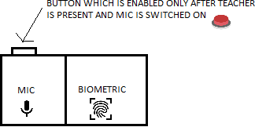

**Figure 4: Block Diagram for Smart Attendance System**

* **Electricity Optimization:**

1. Spatial sensors placed at the edges of classrooms will notify the system of movement and activity in the room.
2. Edge computed algorithms ensure that the lights and fans are turned on only at specific portions of the room incase of a large classroom/hallway.
3. In case of manual fans, temperature monitors are used to add a level of cost-effective automation.

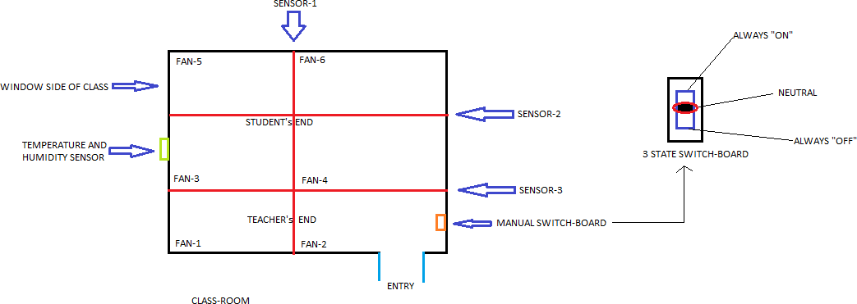

**Figure 5: Block Diagram for Electricity Optimization System**

* We are trying to build a fool-proof system in this project considering the ways students can bypass these systems.
* Real-time implementation of the project that is independent of wiring system of the institutions.
  + 1. **Architecture Choices**

Multiple alternate ways to take attendance were considered however, none of them proved to be as reliable and as viable as our solution as most of them proved to be too unwieldy or posed a security concern or straight up could be tampered with:

* *Attendance Logging via Face Detection:*

Attendance to be logged in via a camera that would use algorithms that would detect faces.

* Pros:

1. Simple and easy for students.
2. Seamless attendance by just showing your face in the camera as you walk in.
3. Zero Time wasted as attendance is taken as students walk in.

* Cons:
  + 1. Very unwieldy, may not work accurately.
    2. Lot of variables deciding its effectiveness such as lighting etc.
    3. Twins and lookalikes may pose an issue.
    4. Actual logging may take time as algorithms take time to recognize faces.
* *Attendance Logging via Single fingerprint scanner:*

Attendance to be logged in via a single fingerprint scanner placed at the entrance of the classroom.

* Pros:
  + 1. Makes the teacher’s life easier as students can manage taking their attendance themselves.
    2. Less expensive as fingerprint scanner to be considered doesn’t need to be portable or high tech.
    3. No inaccuracies as fingerprints are an extremely reliable means of identification.
* Cons:
  + 1. Easier to tamper: Students can just log in to the attendance and walk out of the classroom, hence registering a false attendance.
    2. No overseeing by the teacher as she has no control over classroom- based sensors.

Eventually, our system was devised which provided the maximum balance between functionality and cons:

* *Attendance taken via individual scanners held by teachers:*
* Pros:
  + 1. Teachers have full control over when they can take attendance as the device is constantly with them.
    2. Students cannot fake attendance as the teacher decides when the attendance can be taken once everyone has been settled in the class and the door has been closed.
    3. Students can’t log in attendance and walk out of the class as the device would be passed along in the classroom.
    4. Teachers can give explicit attendance under their own discretion such as when a student walks in late etc.
* Cons:
  + 1. Expensive: Involves the purchase of high-end scanners that can be condensed into portable modules for easy handling.
    2. Involves some time wastage as students need to log in attendance one by one once everyone has settled in.
    3. The device may be prone to damage if it has been extensively being passed on.
    4. **Constraints, Assumptions and Dependencies**
* Availability of Raspberry Pico:

Raspberry Pico is very new to the market and needs to be tested whether it satisfies all the requirements for the project. As per the documentation, it does seem to satisfy them. As a backup, we would still have Raspberry Pi ready, but the cost would be more if we use Raspberry Pi instead of Raspberry Pico.

* Server systems in the Institutions:

Our project also highly depends upon how the server system exists at a particular institution. If there is no existing server, it would be very easy to implement. If there exists a server, then we have to check how exactly we will be able to implement our project on it.

* Existing Wiring in Institutions:

It depends which wiring system exists at the institution because our project would work on almost every existing wiring system unless it’s very old.

* 1. **High Level System Design**
* *Logical User Groups:*
* Teachers:

The teacher is given dashboard permissions to view and manage the attendance and given regular updates as to when the students come to class. The teacher is also given notifications in case of any outliers and can also edit attendance as and when necessary.

* Students:

The students have permissions to only log in the attendance via fingerprint under the teacher’s discretion when the teacher so allows it. The student has no further permissions and if he/she wishes to edit her attendance due to any issue/manual logging, they can only approach the teacher and the teacher can do so under her discretion. The student can also control the temperature of the room and its lighting.

* + - Administrator:

The administrator oversees all the attendance and the database functions. Only the administrator has full access to the database and its core. Every single operation undertaken by the teacher and the student is logged into an audit log. The admin has access to this log and in the event of any emergency/malpractice, the administrator has a clear view of what is happening at all times. He/she also has access to the database and its connections and can undertake any database operations if necessary.

* *Data Components:*
* Raw Fingerprint Data:

This is the raw fingerprint values which registers every time a student scans his/her fingerprint.

* Power Consumption Values:

These values are logged for database analysis purposes. They are the total power consumption values on an hourly basis per classroom.

* Current Room temperature:

This stat is the current room temperature which will be monitored. It is according to this stat that the appliances such as fans will be modulated.

* Database connectors:

All data and actions taken by the device will be relayed onto the database via database connector which will be running on the microcontroller. Every action including the actions of all users in the user groups will be logged via an audit log.

* 1. **Design Description**
     1. **Master Class Diagram (Figure 6)**

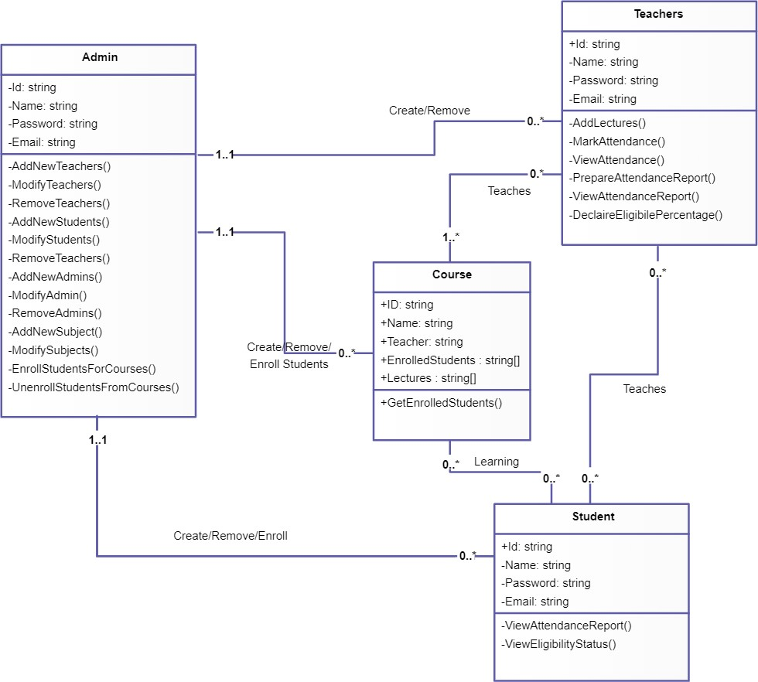

* + 1. **Reusability Considerations**
* The assortment IoT sensors installed in the classrooms are durable and need not be replaced often.
* The server installation too is a one-time process. However, the ThingSpeak and Firebase backends need to be paid for on a yearly basis depending on the usage.
* The ML models used for attendance summarization and fan speed detection are reused and some extra layers(mechanism) have been added on top of that. These models are constantly learning from manual user intervention.
  1. **State Diagrams**
* Attendance: (Figure 7)

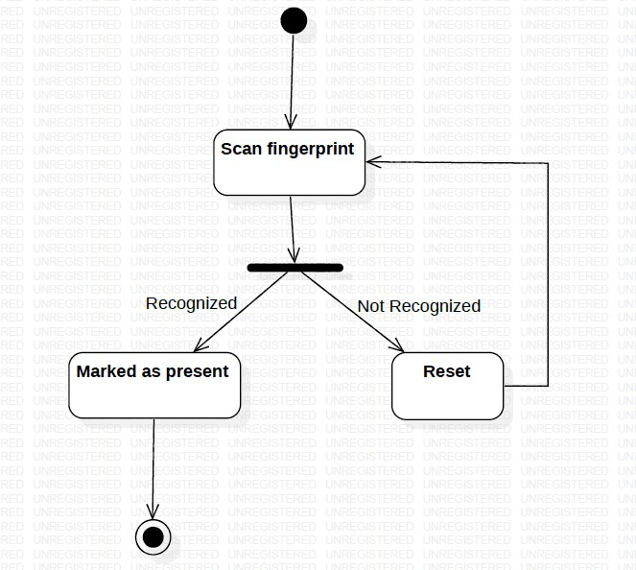

* Electricity Optimization: (Figure 8)

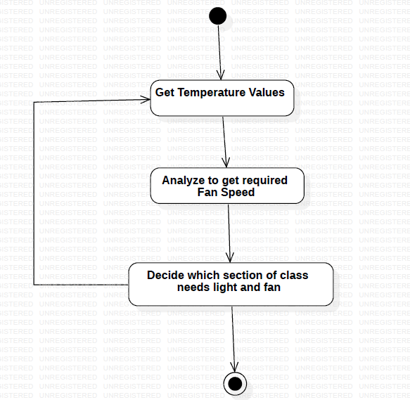

* 1. **User Interface Diagrams (Figure 9)**

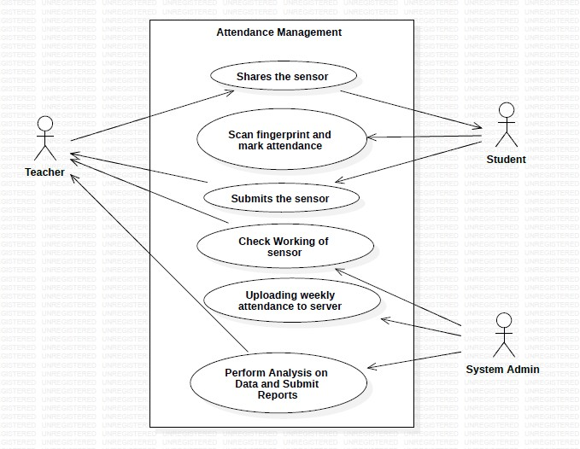

* 1. **External Interfaces**

**User Interfaces**

* Dashboard for the teachers to view attendance.
* Interface for the teachers for manually provide attendance if the sensor fails.
* Controls for the teachers to perform analysis on the intake of students on a per subject basis.
* Controls for the system admin to oversee the registration and authentication of each student.

**Hardware Requirements**

* UART Capacitive Fingerprint Sensor
* Digital temperature controller Thermostat (Model: Absolute Native Electronics W1209 50~100)
* Tolako 5v Relay Module
* PIR Motion Detector Sensor Module HC-SR501
* Microcontroller: Raspberry Pico/ Raspberry Pi
* Transmitter and Receiver for 1km range.

**Software Requirements**

|  |  |  |
| --- | --- | --- |
| Wireless Connectivity | 1 | Wi-Fi Module Specifications:   * Model Number: ESP8266 * Color: Black * Form Factor: All-in-One * Item Weight: 60.0 grams |
| Server | 1 | * ThingSpeak: Home License * Number of messages: 33 million/year for a single unit. (approx. 90,000/day per unit) * Message update interval limit: 1 second * Number of channels: 10 per unit |

**Communication Interfaces**

* Wi-Fi: Connectivity of each of the microcontrollers on every floor will be ensured through Wi-Fi.
* Bluetooth: Connectivity of the fingerprint scammer to the microcontroller will be ensured through Bluetooth.
  1. **Packaging and Deployment Diagram**

Packaging Diagram: (Figure 10)

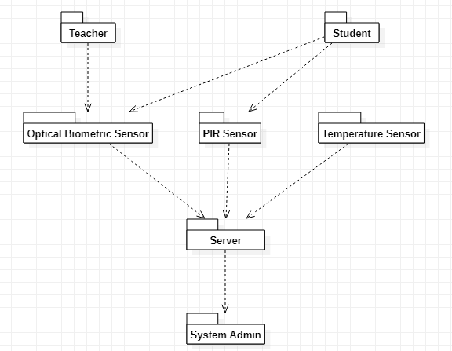

Deployment Diagram:

* Attendance System (Figure 11)

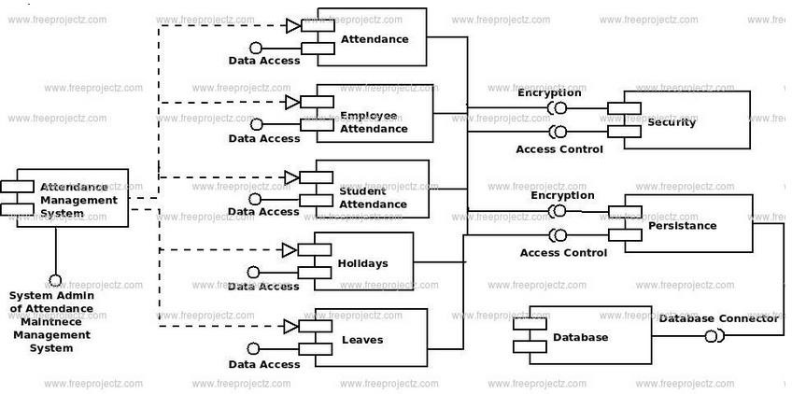

* 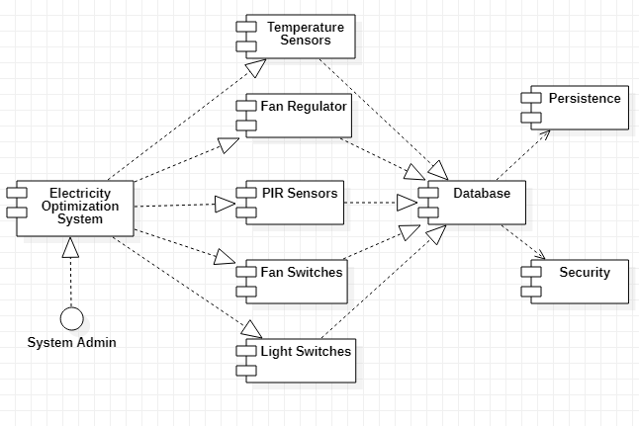Electricity Optimization (Figure 12)
  1. **Help**

A User Manual Page will be provided along with the guidelines and related diagrams for easy installation of our system. It would also contain the maintenance procedure on how to go about using the application and preventing the end user from stalling at any point.

As the admin will be the only point of interaction, a proper documented API documentation will be provided to the administrator. This will be generated using the POSTMAN software.

* 1. **Design Details**
     1. **Novelty**
* Fool proof solution is important keeping in mind the innovative ways students find to bypass attendance systems.
* Real-time implementation that is independent of the wiring system.
  + 1. **Innovativeness**
* Dashboard for the teachers to view attendance.
* Interface for the teachers for manually provide attendance if the sensor fails.
  + 1. **Interoperability**
* Controls for the teachers to perform analysis on the intake of students on a per subject basis.
* Controls for the system admin to oversee the registration and authentication of each student.
  + 1. **Performance**
       - Our product is designed to be extremely versatile, and it doesn’t have any specific conditions to work under and no external factors are going to affect the performance of the product.
       - The fingerprint scanner is also extremely reliable as it will still be able to take a reading regardless of external factors.
       - As for the smart classroom system, the sensors are easily available and are very effective for the use that we are putting them to and are not that easily affected by external factors.
    2. **Security**
* Security is not an issue with our product as the device will always be in the possession of the teacher and all the microcontrollers for the electricity saving model will be in the possession of the floor admin.
* The data collected will be stored safely on a server which is only accessible by the system admin.
  + 1. **Reliability**
* The fingerprint scanner is very reliable and will be able to take the readings irrespective of the external factors and conditions.
* The temperature sensors too are not that easily affected to external factors.
  + 1. **Maintainability**
* The fingerprint scanners would be checked regularly.
* The students also can report to the teachers if there is some problem with the fingerprint scanner.
* The temperature sensors can be replaced occasionally and the best way to know that a sensor is not running is when it does not send any data across or it sends irregular data.
  + 1. **Portability**
* The fingerprint scanner is attached with the mic and will be carried by the respective teachers to the classes they visit.
  + 1. **Reusability**
* After implementation, we can extend this project to various other institutions and organizations.
  + 1. **Application compatibility**
* This system is compatible with any organization and institution since it is independent of the wiring system.

**CHAPTER-6**

**PROPOSED METHODOLOGY**

1. **Attendance Module:**

* Attendance can be taken electronically by means of a biometric optical fingerprint scanner.
* Security and integrity can be ensured by making the biometric module portable and modular - a small phone sized module carried by the teachers.
* The teacher can pass around/have each of the students scan their prints and register their attendance with no manual intervention.

1. **Electricity Optimization Module:**

* Spatial sensors placed at the edges of classrooms will notify the system of movement and activity in the room.
* Edge computed algorithms ensure that the lights and fans are turned on only at specific portions of the room in-case of a large classroom/hallway.
* In case of manual fans, temperature monitors are used to add a level of cost-effective automation.

**CHAPTER-7**

**IMPLEMENTATION AND PSEDUOCODE**

We have attached some screenshots to show the running of our two main modules:

**1. Attendance System Module:**

* Implementation Picture:

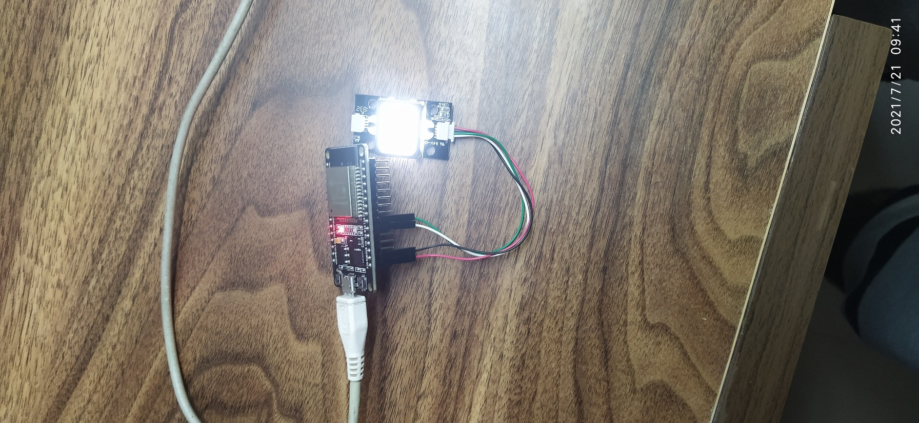

* Arduino Screenshot to successfully enter your ID to the fingerprint scanner:

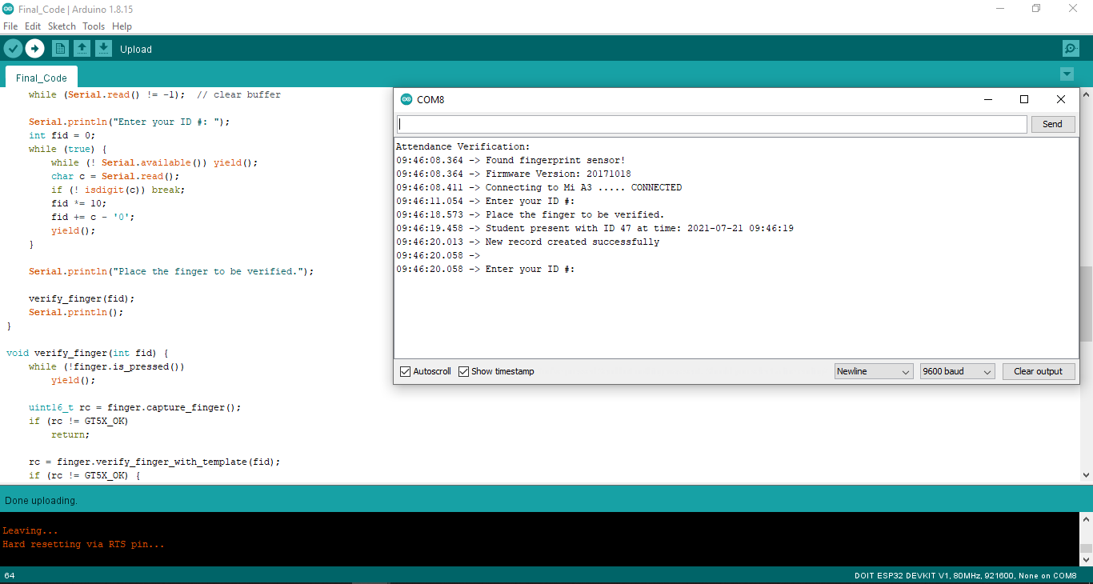

* Database screenshot to showing insertion of data:

* Final database screenshot:

**2. Electricity Optimization Module:**

* Implementation Picture:

* Screenshot of successful run of the program:

**3. Data Visualization Screenshots:**

* Attendance Record of Students:

* Scatter plot between attendance percentage and CGPA:

* Regression line:

**CHAPTER-8**

**RESULTS AND DISCUSSIONS**

**TESTS:**

These are the set of tests we carried for each module:

**Attendance Module:**

* Checking if fingerprint scanner is working or not.
* Checking if fingerprint scanner is able to map the fingerprint to the ID of the student.
* Checking if the data sent to the database is correct or not.

**Electricity Optimization Module:**

* Checking if the module senses motion.
* Checking if the module sends correct data to the database.

**Windows Application:**

* Checking if the app is able to change/update the database.
* Checking if the app is able to handle multiple logins at the same time.
* Checking if the app gives the right data back to the admin.

**Database System:**

* Checking the data sent by fingerprint scanner and map it to the correct class and marking the status.
* Checking the data sent by the electricity optimization module and add correct values to the database.
* Checking of the data given by the system to the admin is correct or not.

**RESULTS:**

* Results are the same as expected from the system.
* All the modules are working as they are supposed to be running.
* The only deviation from the original plan is that we were not able to collect data from all students of a particular class due to the pandemic and only data belonging to the group members is used in this project.

**CHAPTER-9**

**CONCLUSION AND FUTURE WORK**

As we come to the completion of phase-2 of our project, we would like to go over how we have completed the project.

* Identified a valid problem statement.
* Read and went through multiple research papers for reference and ideas to help us formulate a plan to tackle the problem statement.
* Found out Functional and Non-Functional requirements.
* Created a cost estimation document containing all the hardware that will be used also segregating the recurring costs and the onetime costs.
* Compared our design to the old one showing key differences as to why our design is better.
* Created a documented high level design document containing the following:
* Master Class Diagram
* Architecture Choices
* State Diagrams
* User-Interface Diagrams
* External-Interfaces
* Packaging and Deployment Diagrams for both our Solutions.
* Design Details
* Assembled the sensors and other products required for our project.
* Created a prototype of both our modules
* Testing of the built prototypes.
* Integration of both modules to the database.
* Integration of Windows app to all the different modules.
* Data Visualization and Analysis
* AI Model Building
* Final Testing
* Final Demo
* Report Writing

**FUTURE WORK:**

* To extend the project from one institution to multiple institution level.
* Add a couple of other modules to get all-in-one feature system.

**REFERENCES/BIBLIOGRAPHY**

* + - 1. Y. Mehmood, F. Ahmad, I. Yaqoob, A. Adnane, M. Imran and S. Guizani, "Internet-of-Things-Based Smart Cities: Recent Advances and Challenges," in IEEE Communications Magazine, vol. 55, no. 9, pp. 16-24, Sept. 2017, doi: 10.1109/MCOM.2017.1600514.

<https://ieeexplore.ieee.org/abstract/document/8030479>

* + - 1. <https://www.vxchnge.com/blog/iot-statistics>
      2. AItalk: a tutorial to implement AI as IoT devices

<https://ietresearch.onlinelibrary.wiley.com/doi/pdfdirect/10.1049/iet-net.2018.5182>

* + - 1. M. Caţă, "Smart university, a new concept in the Internet of Things," 2015 14th RoEduNet International Conference - Networking in Education and Research (RoEduNet NER), 2015, pp. 195-197, doi: 10.1109/RoEduNet.2015.7311993. <https://ieeexplore.ieee.org/abstract/document/7311993>
      2. Q. Miao, F. Xiao, H. Huang, L. Sun and R. Wang, "Smart attendance system based on frequency distribution algorithm with passive RFID tags," in Tsinghua Science and Technology, vol. 25, no. 2, pp. 217-226, April 2020, doi: 10.26599/TST.2018.9010141. <https://ieeexplore.ieee.org/stamp/stamp.jsp?tp=&arnumber=8821515>
      3. J. Yu, W. Gong, J. Liu, L. Chen, K. Wang and R. Zhang, "Missing Tag Identification in COTS RFID Systems: Bridging the Gap between Theory and Practice," in IEEE Transactions on Mobile Computing, vol. 19, no. 1, pp. 130-141, 1 Jan. 2020, doi: 10.1109/TMC.2018.2889068. <https://www2.cs.sfu.ca/~jcliu/Papers/MissingTagIdentification.pdf>
      4. Suresh S., H. N. S. Anusha, T. Rajath, P. Soundarya and S. V. P. Vudatha, "Automatic lighting and Control System For Classroom," 2016 International Conference on ICT in Business Industry & Government (ICTBIG), 2016, pp. 1-6, doi:10.1109/ICTBIG.2016.7892666. <https://ieeexplore.ieee.org/abstract/document/7892666>
      5. S. Bhattacharya, G. S. Nainala, P. Das and A. Routray, "Smart Attendance Monitoring System (SAMS): A Face Recognition Based Attendance System for Classroom Environment," 2018 IEEE 18th International Conference on Advanced Learning Technologies (ICALT), 2018, pp. 358-360, doi: 10.1109/ICALT.2018.00090. <https://ieeexplore.ieee.org/abstract/document/8433537>
      6. IOT AND AI IN HEALTHCARE: A SYSTEMATIC LITERATURE REVIEW <https://iacis.org/iis/2018/3_iis_2018_33-41.pdf>
      7. S. M. Felix, S. Kumar and A. Veeramuthu, "A Smart Personal AI Assistant for Visually Impaired People," 2018 2nd International Conference on Trends in Electronics and Informatics (ICOEI), 2018, pp. 1245-1250, doi: 10.1109/ICOEI.2018.8553750. <https://ieeexplore.ieee.org/abstract/document/8553750>
      8. V. Chamola, V. Hassija, V. Gupta and M. Guizani, "A Comprehensive Review of the COVID-19 Pandemic and the Role of IoT, Drones, AI, Blockchain, and 5G in Managing its Impact," in IEEE Access, vol. 8, pp. 90225-90265, 2020, doi: 10.1109/ACCESS.2020.2992341.

<https://ieeexplore.ieee.org/abstract/document/9086010>

* + - 1. A review on intelligent process for smart home applications based on IoT: coherent taxonomy, motivation, open challenges, and recommendations.

<https://link.springer.com/article/10.1007/s10462-018-9648-9>

13. W. Chen, Y. Lin, F. Ng, C. Liu and Y. Lin, "RiceTalk: Rice Blast Detection Using Internet of Things and Artificial Intelligence Technologies," in IEEE Internet of Things Journal, vol. 7, no. 2, pp. 1001-1010, Feb. 2020, doi: 10.1109/JIOT.2019.2947624.

<https://ieeexplore.ieee.org/document/8871173>

14. D. He and S. Zeadally, "An Analysis of RFID Authentication Schemes for Internet of Things in Healthcare Environment Using Elliptic Curve Cryptography," in IEEE Internet of Things Journal, vol. 2, no. 1, pp. 72-83, Feb. 2015, doi: 10.1109/JIOT.2014.2360121. <https://ieeexplore.ieee.org/document/6907930>

15. R. Sarmah, M. Bhuyan and M. H. Bhuyan, "SURE-H: A Secure IoT Enabled Smart Home System," 2019 IEEE 5th World Forum on Internet of Things (WF-IoT), 2019, pp. 59-63, doi: 10.1109/WF-IoT.2019.8767229.

<https://ieeexplore.ieee.org/document/8767229>

**APPENDIX A:**

**DEFINITIONS, ACRONYMS AND ABBREVIATIONS**

* ThingSpeak: Open-source IoT application and API to store and retrieve data from things using the HTTP and MQTT protocol over the Internet or via LAN.
* Capacitive Fingerprint Scanner: uses capacitance to gauge the depth of the finder and collect the fingerprint.
* Relay: A relay is an electrically operated switch. It consists of a set of input terminals for a single or multiple control signals, and a set of operating contact terminals.
* Thermostat: A thermostat is a regulating device component which senses the temperature of a physical system and performs actions so that the system's temperature is maintained near a desired setpoint.
* Microcontroller: A microcontroller is a small computer on a single metal-oxide-semiconductor integrated circuit chip.

**APPENDIX B: USER MANUAL**

**1. Attendance Systems:**

* Attendance can be taken electronically by means of a biometric optical fingerprint scanner.
* Security and integrity can be ensured by making the biometric module portable and modular - a small phone sized module carried by the teachers.
* The teacher can pass around/have each of the students scan their prints and register their attendance with no manual intervention.

**2. Electricity Optimization:**

* Spatial sensors placed at the edges of classrooms will notify the system of movement and activity in the room.
* Edge computed algorithms ensure that the lights and fans are turned on only at specific portions of the room incase of a large classroom/hallway.
* Incase of manual fans, temperature monitors are used to add a level of cost-effective automation.